Exceptional Opportunity
Wellspring Academy Trust
Post Title: | Cover Supervisor Hours: 32.5 hours per week, TTO + 5 days
Reporting to: | Head of School | Salary: | SCP pt 13-17 (C1)
Wellspring Academy Trust is a growing Multi-Academy Trust with twenty-eight Academies, making the Trust one of the largest in the North. We are committed to making a difference to the lives and life chances of the young people and the communities we serve and believe in the potential of our team to achieve remarkable things.
An opportunity has arisen for a Cover Supervisor to join our team at Victoria Primary Academy. We are looking for a teammate who believes in the infinite potential of little people and is passionate about their role in unlocking their future. We welcome applications from those with experience in schools who are keen to develop expertise in their work. The school is at an exciting point in its journey, with the next few years highly focused on developing excellence in all that we do. No matter what your personal aspirations for the future are and whatever stage in your career you are at – this could be the role which enables you to take the leap into that future.
You will enjoy a diverse role with the opportunity to both lead classroom teaching and support pupils’ learning in the classroom, to lead catch -up tuition sessions and play a full part within the school community.
We are fully committed to your professional development and believe we have the perfect conditions for growth amongst warm and friendly colleagues.
At Victoria Primary Academy, situated in Leeds 9, you will discover a building jam-packed full of beautiful little people, and teaching teams who are passionate about offering the very best quality provision in all aspects of the school experience – because we simply believe they deserve nothing less. We have a strong desire to ensure that our children have everything that they need to become successful adults when they leave us. If you are passionate about improving the life-chances of young people, then this could be the opportunity you have been seeking.
Visit our website https://vpaleeds.co.uk/ for more information about our school.

If you:
- Are enthusiastic about building positive relationships with children and adults alike
- Are committed to your own professional development
- Are a strong team player who enjoys collaboration with colleagues
- Have experience of leading learning in group and whole class situations
- Are passionate about every child’s entitlement to good quality learning
…then we want to hear from you.
What can we offer?
- Fantastic kids
- A supportive and dedicated team who enjoy high levels of collaboration
- A fun filled career where you can truly make a difference
- Opportunities for your own professional development

Interested applicants are invited to speak with Executive Principal, Sam Bailey, to find out more.

Wellspring Academy Trust is committed to safeguarding and promoting the welfare of our pupils. All posts are offered subject to enhanced DBS checks. References will be taken up prior to interview.

If you are currently living overseas or have lived / worked overseas in the last five years please be aware that you will be required to provide an overseas criminal records check from the country/countries you have resided in, if you are the preferred candidate for the post.
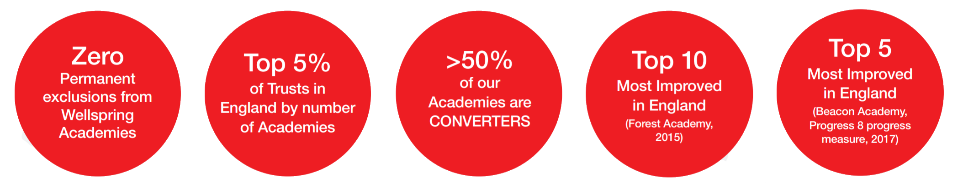

Reporting to | Head of School
Duration of Post | Permanent
Hours | 32.5 hours per week (8.30-3.30) TTO+5 days
Salary | SCP 13-17 (C1)
Start Date | June 2022
Closing Date | 28th April 2022
Interview Date | 6th May 2022
Applications | For further information about the role, candidates are warmly encouraged to visit us. To arrange an appointment or to return your completed application, please contact jeni.mccormack@eborgardensprimaryacademy.co.uk

