


Post Title: KS1 Class Teacher (Maternity Cover)
Reporting to: Principal / Vice Principal
Salary: MPS 1-6
Contract type: Fixed Term – 01 January 2024 until 31 August 2024
Wellspring Academy Trust is a growing Multi-Academy Trust with an increasing number of Academies and ambitions for further growth in future years. We are committed to making a difference to the lives and life chances of the young people and the communities we serve.
An exciting opportunity has arisen at Ebor Gardens for an exceptional class teacher to join our team and to take advantage of the opportunity to work alongside talented colleagues who are passionate about offering the very best quality provision in all aspects of the school experience for our little people: we simply believe they deserve nothing less. We have a strong desire to ensure that our children have everything that they need to become successful adults when they leave us. If you are passionate about improving the life chances of young people then this could be the right place for you.
If you are:
- A good teacher who has a thorough understanding of engaging children and eliciting their best.
- Passionate about the achievement of all children and doing ‘whatever it takes’ to secure pupil progress.
- Enthusiastic about your role within a school team who are ambitious for the future.
- Committed to your own professional development.
- A strong team player who enjoys collaboration with colleagues
…then we need you on the team. What can we offer?
• Fantastic children who bring an abundance of potential.
• A supportive and dedicated team who enjoy high levels of collaboration.
• A consistent approach to curriculum, assessment, teaching and learning, based on the professional collaboration of staff across our partnership of schools
• Brilliant professional development opportunities, from the earliest stages of teaching through to senior
leadership.

If you know that Ebor Gardens is the right school for you – please complete your application and send it to Jeni McCormack, Office Manager, ahead of the deadline. Please complete the attached link when submitting your application http://bit.ly/WATEqualOpportunities

Wellspring Academy Trust is committed to safeguarding and promoting the welfare of our pupils. All posts are offered subject to enhanced DBS checks. References will be requested and an online search carried out for shortlisted candidates, prior to attendance at interview. Further pre-employment checks, including prohibition from teaching, childcare disqualification and section 128 checks, if deemed relevant for the role, will be completed for the successful candidate upon acceptance of the post.

If you are currently living overseas or have lived / worked overseas in the last five years please be aware that you will be required to provide an overseas criminal records check from the country/countries you have resided in, if you are the preferred candidate for the post.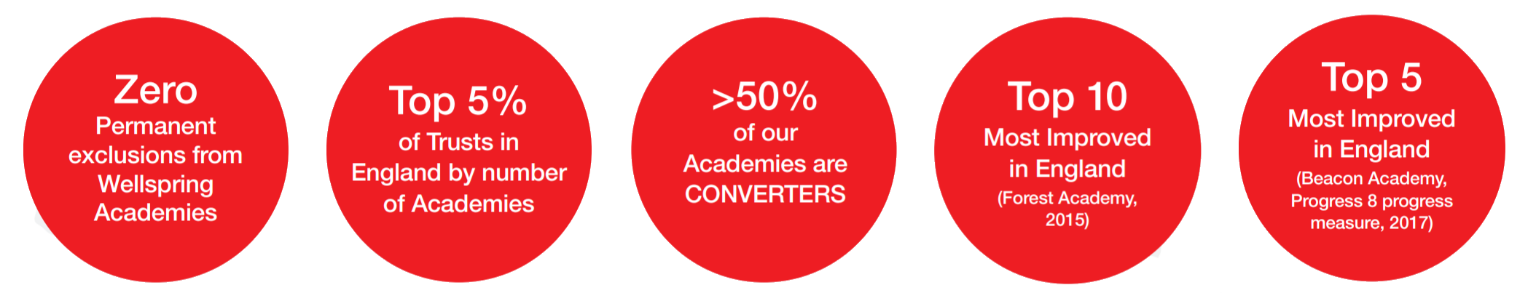

Reporting to | Principal / Vice Principal
Duration of Post | Fixed Term – 1st Jan 2024 – 31st Aug 2024
Hours | Full-time
Salary | MPS 1-6
Start Date | January 2024
Closing Date | Friday 20th October 2023, 12 noon
Interview Date | Thursday 26th October 2023
Applications | Completed application forms should be returned to Jeni McCormack jeni.mccormack@eborgardensacademy.co.uk
www.wellspringacademytrust.co.uk

